A Practical activity Report submitted

for Engineering Design Project-II (UTA-024) by

# Name of student Roll number

**Pulkit Arora 102103267**

**Submitted to**



DEPARTMENT OF ELECTRONICS AND COMMUNICATION ENGINEERING

# THAPAR INSTITUTE OF ENGINEERING AND TECHNOLOGY, (A DEEMED TO BE UNIVERSITY), PATIALA, PUNJAB

**INDIA**

# Jan-May 2023

# Experiment: 3

**Objective:** (a) To draw a schematic diagram of pulse width modulation (PWM) based transmitter for generating specified pulse width waveforms for gantries placed at different locations on the path using CAD tool (Eagle).

(b) To design a printed circuit board layout of pulse width modulation (PWM) based transmitter using CAD tool (Eagle).

**Software Used:** Eagle Software

# Component Used:

|  |  |  |  |  |
| --- | --- | --- | --- | --- |
| **Sr. No.** | **Name of Component** | **Value** | **Description** | **Quantity** |
| 1. | Resistor | 330 Ω | Carbon resistor with 5% Tolerance | 1 |
| 2. | Capacitor | 100 pF | Ceramic Capacitor | 1 |
| 3. | Capacitor | 1 uF | Ceramic Capacitor | 1 |
| 4. | DCJ0202 |  | DC Power Jack | 1 |
| 5. | IC 7805 T |  | Voltage Regulator | 1 |
| 6. | LED3MM |  | Light Emitting Diode | 1 |
| 7. | ATTiny85 |  | 8-bit Microcontroller | 1 |
| 8. | 22-23-2031 |  | PCB Header | 3 |

**Theory :**

1. **Resistor**:

A resistor is a passive two-terminal electrical component that implements electrical resistance as a circuit element. In electronic circuits, resistors are used to reduce current flow, adjust signal levels, to divide voltages, bias active elements etc .

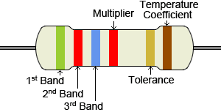

Fig 3.1

1. **Capacitor**:

A capacitor is a device that stores electrical energy in an electric field. It is a passive electronic component with two terminals.

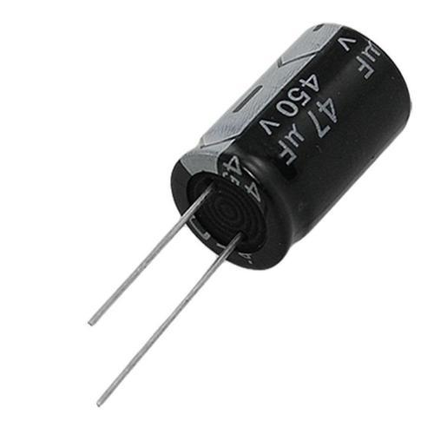

Fig 3.2

3.DCJ0202: It is a power jack/connector. This is a common barrel-type power jack for DC wall supplies. These are compatible with our DC wall supplies and have a 5.5 mm jack with a 2.1 mm centre pole diameter.

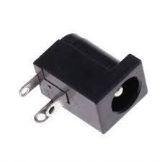

Fig 3.3

1. IC 7805 T: It is a three terminal (input, output and ground) voltage regulator. The name signifies two meanings:”78” means that it is a positive voltage regulator and “05” means that it provides 5V as output.

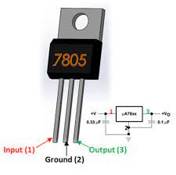

Fig 3.4

\

1. LED3MM

A light-emitting diode is a semiconductor device that emits light when

current flows through it. Electrons in the semiconductor recombine with electron

holes, releasing energy in the form of photons. 3mm LEDs are the smallest and used.

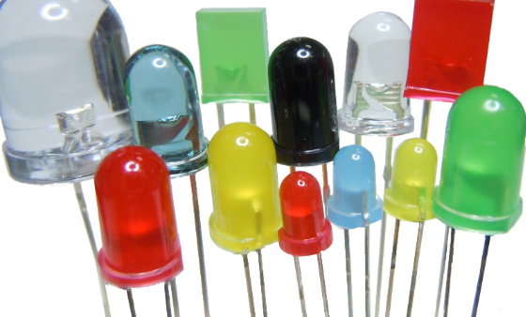

Fig 3.5

1. ATTiny85: The ATtiny85 is a low-power CMOS 8-bit microcontroller based on the AVR enhanced RISC architecture. By executing powerful instructions in a single clock cycle, the ATtiny85 achieves throughputs approaching 1 MIPS per MHz allowing the system designer to optimize power consumption versus processing speed.

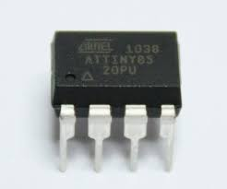

Fig 3.6

1. 22-23-2031:22-23-2031 is a wire to board connector having 2.54 mm pitch and three contacts. It has nylon as its housing material.

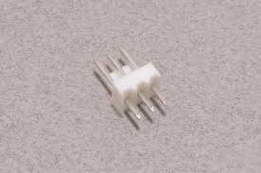

Fig 3.7

# Schematic diagram:

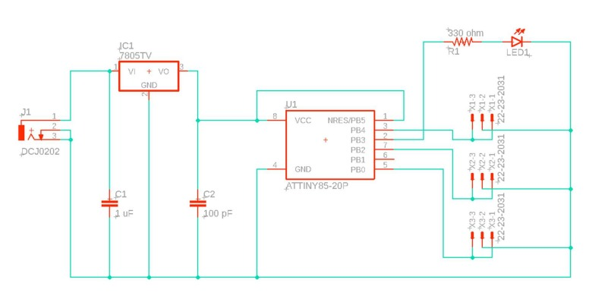

# Fig 3.8

# Printed Circuit Board layout:

# 

# Fig 3.9

Discussion:

In this Lab we have learnt how to use the EAGLE SOFTWARE & the circuit diagram of pulse width modulation based transmitter circuit has been studied and its layout has been made using EAGLE SOFTWARE. Also various functionalities of components like resistors, ATiny 85 micro controller,

Voltage regulator, DC power jack have been studied.

# 

Signature of Faculty member